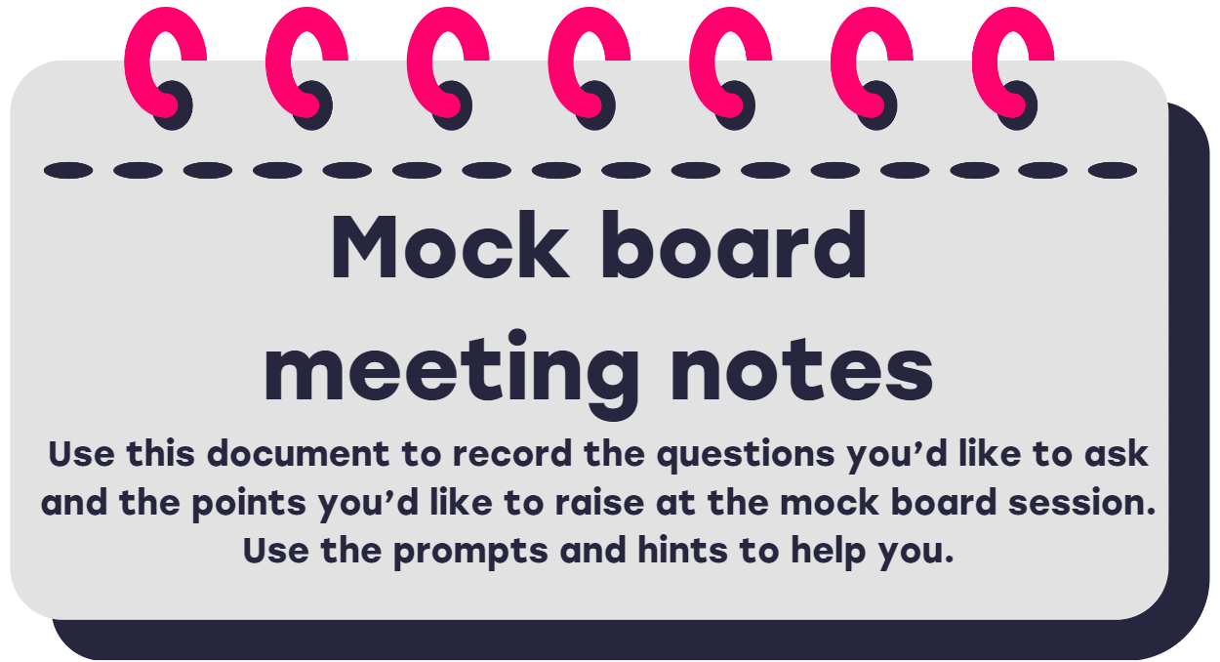

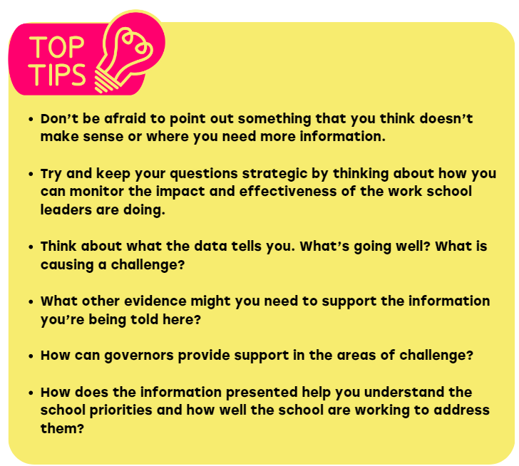

Headteacher’s report

|  |  |  |
| --- | --- | --- |
| Page | Things for you to think about | Questions you want to ask at the meeting |
| 1 | These are the main areas of improvement for the school. How does the information in the report tell you how well the school is addressing these? |  |
| 2 | What does this tell you about the school? What else might you need to know? |  |
| 3 | What does this data tell you about behaviour in the school? Is there anything you else you need to know that this data doesn’t tell you? |  |
| 4 | What does this data tell you about behaviour in the school? What else might you need to know to understand how effectively the school are dealing with attendance? |  |
| 5 | What does this data tell you? Does this information tell you everything you need to know how effective safeguarding, SEND and GDRP is at the school? |  |
| 6 | What does this data tell you? What else might you want to know about to get a good understanding of these areas? |  |
| 1-6 | Are there are other questions or comments you’d like to make about this report? |  |

Progress and attainment report

|  |  |  |
| --- | --- | --- |
| Page | Things for you to think about | Questions you want to ask at the meeting |
| 1 | Why do we look at progress data? What questions might you ask about the difference in Progress data over the last few academic years?  What is the difference between progress and attainment data?  What does the data tell you?  What might you want to ask about what has gone well and what hasn’t? |  |
| 2 | What might have had an impact on the pass rate for the Year 1 phonics test?  What else do you need to know about how the school is supporting effective teaching and learning of phonics in Key Stage 1? |  |
| 3 | What are the particular strengths?  Where are the challenges?  What questions can you ask about the focus on strategies being put in place?  What does this information tell you to support your understanding of how the school are addressing their priorities? |  |
| 1-3 | Are there are other questions or comments you’d like to make about this data? |  |